Resume

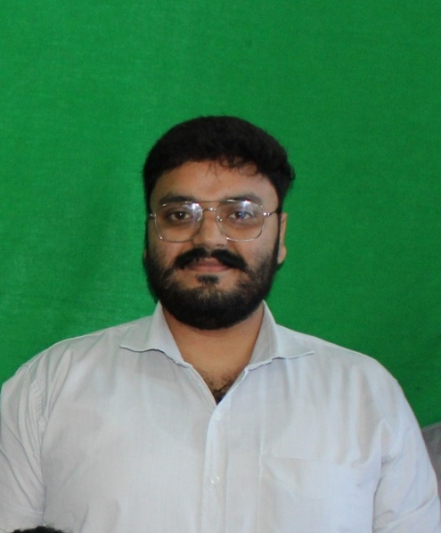

PULKIT VERMA

WEB DEVELOPER

Being a web developer is my dream because it’s a creative job with many challenges.

EDUCATION

**V.K.S. PUBLIC SCHOOL**

2017 - 2018 | INTERMEDIATE

EXPERIENCE

2018

**VISION INDIA PVT. LTD**

ASSOCIATE B.P.O.

**I.F.T.M. UNIVERSITY**

2018-2021 | Bachelor's Of Computer Applications

2019

**A.C.T.C. COMPUTER INSTITUTE**

TEACHER

Tasked to teach coding languages and all other stuff.

SKILLS

PHP Web Development Basics Of WordPress Intermediate Knowledge Of Codeigniter Framework.

Manage Front-End Work

Knowledge of Javascript, Jquery

2021

**SOLIDALE INFOTECH PVT. LTD.**

WEB DEVELOPER

Tasked to develop CRM's, Admin Panel's etc.

Created concepts for many client's.

+91 9368552604 +91 7830312859 [pulkitverma.mbd@gmail.com](mailto:pulkitverma.mbd@gmail.com)