**Resume**

|  |
| --- |
| **Name: Vishv Nath** |

|  |  |  |  |  |
| --- | --- | --- | --- | --- |
| **Present Address** | | **Contact Details** | |  |
| Sharaffabad sector 73,Noida 201301 | | **Mobile:** | 9756505197,6395088623 |
| **Land Line No.** |  |
| **E-Mail:** | avithakur1571994@gmail.com |
| **Career Objective:** | | “Looking forward to an opportunity for working in a dynamic, challenging environment, where I can utilize my skills for developing my career and for the growth of the organization”. | | |
| **Branch/ Stream:** Master of computer application(M.C.A) | | | | |
| **Educational Qualifications: (Stream :**-**)** | | | | |
| |  |  |  |  |  |  | | --- | --- | --- | --- | --- | --- | | **Exam** | **Year** | **College & Board** | **Main Subjects** | **Marks%** | **Remarks** | | M.C.A | 2020 | Hindustan institute of management and computer studies(A.K.T.U | Computer  Science | 68.3 |  | | B.C.A | 2017 | Manorma institute of managrment and technology ladamda agra | Computer  Science | 60.8% |  | | Intermediate | 2014 | Shri jagdish SSIC Surothi agra | PCM | 56% |  | | High School | 2012 | GSK Intercollege kiraoli agra | Math,hindi,eng,  Science,Socialscience,drawing | 69.1 |  | | | | | |
|  | | | | |
|  | | | | |
| **Professional Skills:** |  | | | |
| * **Database** : Oracle, Mysql * **Web Technology:** HTML ,CSS,JS * **Language:** JAVA, C, PHP | | | | |
| **Projects:** |  | | | |
| **Organisation :** Hindustan institute of management and computer studies  **Duration :** 3 months  **Project Title :** Billing System  **Platform :** PHP  **Tool Used** :,Xamp, sublime | | | | |
| **Additional Information / Achievements:** | | |  | |
| * Participated and won in various competitions at colleges * Internship in PHP during 6 months from B2E Coder | | | | |
| **Personal Details** | | | **Permanent Address / Contact Details** | |
| **Father's Name:** | | Shri Krishna Nath | Aulenda,fatehpur sikhri agra 283110 | |
| **D.O.B:** | | 15-01-1995 |

|  |  |  |
| --- | --- | --- |
| **Language Proficiency:** | Hindi , English | **Permanent Phone No./ Father’s Phone –**975650519**7** |

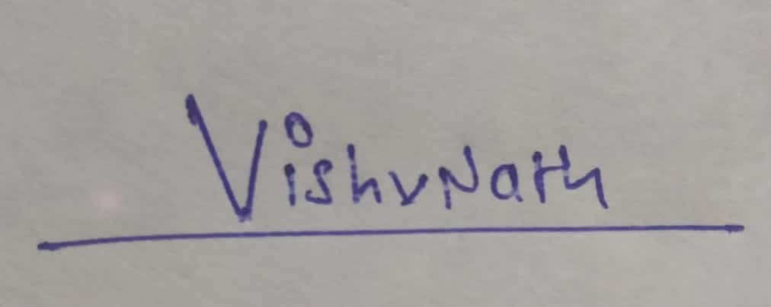

------------------------------ **Signature**